Vectors

Quantities that have direction as well as magnitude are called as vectors. Examples of vectors are velocity, acceleration, force, momentum etc.

Vectors can be added and subtracted. Let a and b be two vectors. To get the sum of the two vectors, place the tail of b onto the head of a and the distance between the tail of a and b is a+b.

Multiplication of a vector by a positive scalar k multiplies the magnitude but leaves the direction unchanged. If k=2 then the magnitude of a doubles but the direction remains the same.

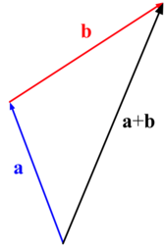
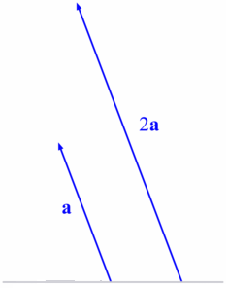

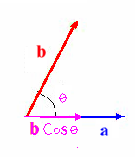
Dot product of two vectors is the product of a vector to the projection of the other vector on the vector. a. b is called the dot product of the two vectors.
a. b = $\left|a\right|\left|b\right|\text{cos}θ$. If the two vectors are parallel, then a. b =$\left|a\right|\left|b\right|$ and if the two vectors are perpendicular to each other, then a. b = 0

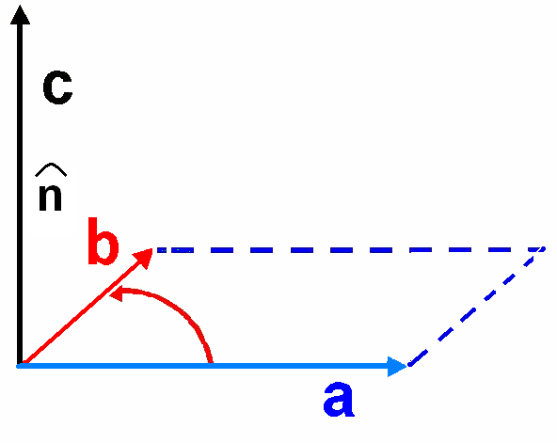
Cross Product of any two vectors is defined by a b= c =$\left|a\right|\left|b\right|\text{sin}θ$$\hat{n}$, where $\hat{n}$ is a unit vector (vector of length 1) pointing perpendicular to the plane of a and b. But as there are two directions perpendicular to any plane, the ambiguity is resolved by the right hand rule: let your fingers point in the direction of the first vector and curl around (via the smaller angle) towards the second; then your thumb indicates the direction of$\hat{n}$.

A Unit vector is a vector whose magnitude is 1 and point is a particular direction. Without loss of generality, we can assume $\hat{i},\hat{j},\hat{k}$to be three distinct unit vectors along the x, y, and z-axis relatively.
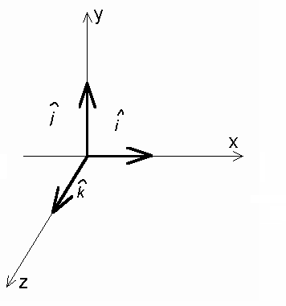
Then,
$\hat{i}⋅\hat{i}=\hat{j}⋅\hat{j}=\hat{k}⋅\hat{k}=1$ and $\hat{i}⋅\hat{j}=\hat{j}⋅\hat{k}=\hat{k}⋅\hat{i}=0$
Also,
$\hat{i}×\hat{i}=\hat{j}×\hat{j}=\hat{k}×\hat{k}=0$
$\hat{i}×\hat{j}=−\hat{j}×\hat{i}=\hat{k}$
$\hat{j}×\hat{k}=−\hat{k}×\hat{j}=\hat{i}$
$\hat{k}×\hat{i}=−\hat{i}×\hat{k}=\hat{j}$

In cylindrical coordinate systems, a vector$\vec{A}=A_{s}\hat{s}+A_{φ}\hat{φ}+A_{z}\hat{z}$, where $\hat{s},\hat{φ},\hat{z}$are the unit vectors of the coordinate system.
In spherical coordinate system, a vector$\vec{A}=A_{r}\hat{r}+A_{θ}\hat{θ}+A_{φ}\hat{φ}$, where $\hat{r},\hat{θ},\hat{φ}$ are the unit vectors of the coordinate system.

Vector Questions

1. Consider three vectors:

$$\begin{aligned}\vec{A}=3\hat{i}+0\hat{j} \\ \vec{B}=2\sqrt{3}\hat{i}+2\hat{j} \\ \vec{C}=−5\hat{i}+5\sqrt{3}\hat{j}\end{aligned}$$

a. Draw the three vectors.
b. What is the length or magnitude of$\vec{A}$, $\vec{B}$and$\vec{C}$?
c. What is the angle between $\vec{A}$and$\vec{C}$, $\vec{A}$and$\vec{B}$, $\vec{B}$and$\vec{C}$?

2. Consider three vectors:

$$\begin{aligned}\vec{A}=4\hat{i}+6\hat{j}−2\hat{k} \\ \vec{B}=2\hat{i}+7\hat{j}−1\hat{k} \\ \vec{C}=0\hat{i}+3\hat{j}+5\hat{k}\end{aligned}$$

a. What is the length or magnitude of$\vec{A}$, also written as$\left|\vec{A}\right|$?
b. Write the expression for 2$\vec{A}$.
c. What is$\vec{A}+\vec{B}$ ?
d. What is$\vec{C}−\vec{A}$ ?
e. What is$\vec{C}×\vec{A}$ ?
f. What is the magnitude of$\vec{C}×\vec{A}$ ?
g. What is$\vec{B}⋅\vec{C}$?
h. What is the angle between $\vec{A}$ and $\vec{C}$ ?
i. Does $\vec{B}⋅\vec{C}$equal$\vec{C}⋅\vec{B}$?
j. How is $\vec{C}×\vec{A}$ and $\vec{A}×\vec{C}$related?
k. Give an example of the use of dot product in Physics and explain.
l. Give an example of the use of cross product in Physics and explain.
m. Imagine that the vector $\vec{A}$ is a force whose units are given in Newtons. Imagine vector $\vec{B}$is a radius vector through which the force acts in meters. What is the value of the torque$(\vec{τ}=\vec{r}×\vec{F})$, in this case?
n. Now imagine that $\vec{A}$continues to be a force vector and $\vec{C}$ is a displacement vector whose units are meters. What is the work done in applying force $\vec{A}$ through a displacement$\vec{C}$?
o. What is the vector sum of a vector $\vec{D}$ given by 40 m, 30 degrees and a vector $\vec{E}$given by 12 m, 225 degrees? Use the method of resolving vectors into their components and then adding the components.

3. Consider three vectors:

$$\begin{aligned}\vec{A}=−3\hat{i}+3\hat{j}+2\hat{k} \\ \vec{B}=−2\hat{i}−4\hat{j}+2\hat{k} \\ \vec{C}=2\hat{i}+3\hat{j}+1\hat{k}\end{aligned}$$

A. Find$\vec{A}⋅(\vec{B}+\vec{C})$.
b. Find$\vec{A}⋅(\vec{B}×\vec{C})$.
c. Find$\vec{A}×(\vec{B}+\vec{C})$.

